|  |
| --- |
| **STANDARD OPERATING PROCEDURE** |
| |  |  | | --- | --- | | **Title: Liquid Chromatography** | | | **SOP#: LC-02** |  | | **Version #: 1** | **Author: Paulovich Lab** | | **Date Approved:** | **Date Modified:** | |

1. PURPOSE

The purpose of this document is to describe the liquid chromatography (LC) method for quantitative analysis.

1. SCOPE

This procedure encompasses the setup of the LC and method parameters.

1. RESPONSIBILITIES

It is the responsibility of person(s) performing this procedure to be familiar with laboratory safety procedures. The interpretation of results must be done by a person trained in the procedure and familiar with such interpretation.

1. Equipment

HPLC: Eksigent Classic 2D

1. Materials

Injection loop: 10 L peeksil, 100 m ()

Column: 75 µm x 12 cm Reprosil AQ C18 3 µm

Water, HPLC grade (H2O) (Fisher, W5-1)

Acetonitrile, HPLC grade (ACN) (Fisher, A998-1)

Formic Acid (FA) (EDM, 11670-1)

1. Reagents

Mobile phases. Must be degassed every week:

Gradient 1, mobile phase A: 0.1% FA in H2O

Gradient 1, mobile phase B: 0.1% FA in 90% ACN

Gradient 2, mobile phase A: 0.1% FA in H2O

Gradient 2, mobile phase A: 0.1% FA in 90% ACN

Loading Pump: 0.1% FA in H2O

1. Procedure

LC Configuration and Method Tables

Plumbing Diagram (A): tubing length and i.d.

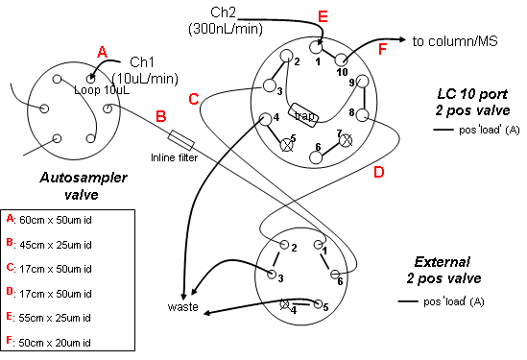

Autosampler Methods:



Liquid Chromatograph Methods:

1. Set Column heater to 45°C.

2. Program Channel 1 conditions to Conserved flow mode, Sample injection = none, and Pre-column flushing = ON.

3. Fill solvent reservoirs as follows:

Ch1 A: 100% H2O:0.1% formic acid.

Ch1 B: 90% acetonitrile:0.1% formic acid.



5. Channel 2 conditions: Independent flow mode, Sample injection = none, and Pre-column flushing = ON.

3. Fill solvent reservoirs as follows:

Ch2 A: 100% H2O:0.1% formic acid.

Ch2 B: 90% acetonitrile:0.1% formic acid.

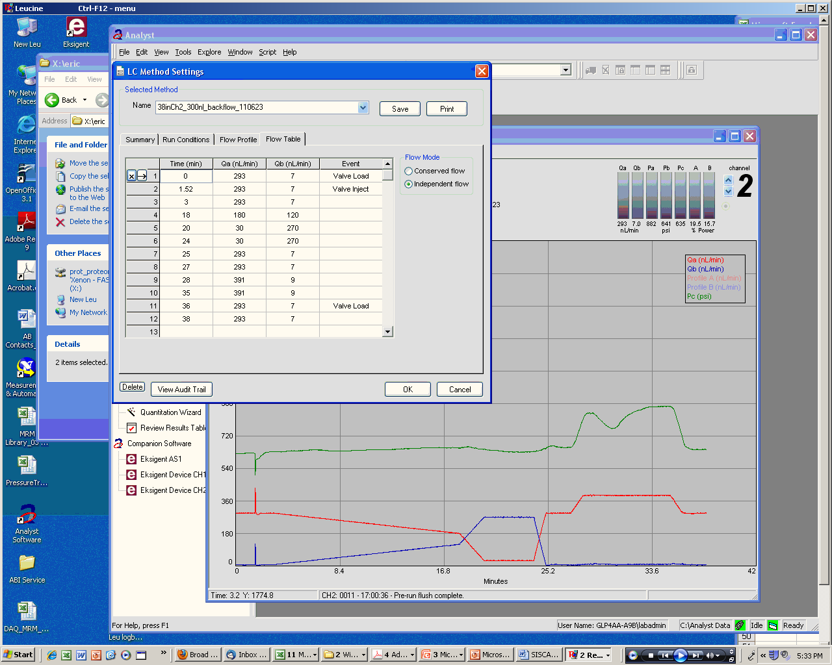

LC and MS checklists and MRM method

|  |  |  |
| --- | --- | --- |
| HPLC SOP Checklist | | |
| **Parameter** | **Value** | **Notes** |
| Autosampler temperature | 8°C |  |
| Column dimensions | 10 cm x 75 µm **INTEGRAFRIT**  total fused silica length = 17cm |  |
| Precolumn dimensions | 5 mm x 0.3 mm |  |
| Column packing material | Reprosil 3 µm |  |
| Column temperature | **45C** |  |
| Mobile phase A | 0.1% (v/v) formic acid in water |  |
| Mobile phase B | 0.1% (v/v) formic acid in 90% acetonitrile |  |
| Injection loop (or needle) volume | 10.0 uL |  |
| Flow rate for gradient | 300 nL/min |  |

1. Referenced Documents